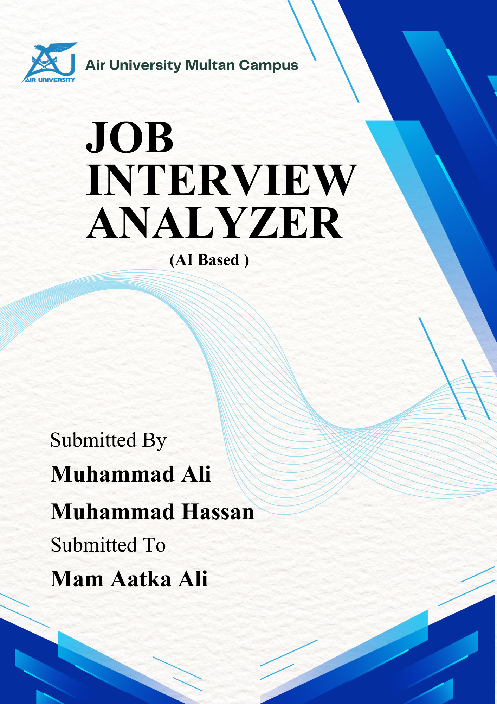


Project Report
Roll No:
Muhammad Ali 233510
Muhammad Hassan 233516
Class:
BSCS
Section:
B
Semester:
5th
Course:
Artifical Intelligence (CS 344)

Submission Date:
26 December 2025

Contents
1.Introduction 3
2. Problem Statement 4
3. Objectives 5
4. Literature Review 6
4.1 Facial Emotion Recognition 6
4.2 Speech Emotion Recognition 7
4.3 Multimodal Emotion Fusion 7
4.4 Interview Analysis Systems 8
5. System Design and Methodology 8
5.1 System Architecture 8
5.2 Methodology 9
5.2.1 Facial Emotion Detection Pipeline 9
5.2.2 Speech Emotion Recognition Pipeline 9
5.2.2 Multimodal Fusion Algorithm 10
6. Implementation Details 10
6.1 Technology Stack 10
6.2 Core Modules 11
6.2.1 Face Emotion Analyzer (face_emotion.py) 11
6.2.2 Realtime Speech Emotion Recognizer (realtime_speech_emotion.py) 12
6.2.3 Multimodal Fusion (fusion.py) 12
6.3 Pre-trained Models 13
6.4 Web Interface 13
6.5 Dataset Description 13
6.5.1 Facial Emotion Dataset – FER2013 14
6.5.2 Speech Emotion Dataset – RAVDESS 15
6.6 AI Models Description 17
6.6.1 Selected AI Algorithms 17
6.6.2 Mathematical Intuition 17
6.6.3 Multimodal Fusion Logic 18
6.6.4 Training and Testing Approach 18
6.6.5 Evaluation Metrics 19
7. Results and Discussion 19
7.1 System Performance 19
7.2 Sample Analysis Output 19
7.3 Strengths 21
7.4 Limitations 21
Model Accuracy and Evaluation 22
7.5 Discussions 22
8. Conclusion and Future Work 22
8.1 Conclusion 22
8.2 Future Work 23
9. References 24

Topic
AI Based – Job Interview Analyzer

1.Introduction
The AI Interview Analyzer is a real-time artificial intelligence-powered system designed to analyze and evaluate interview performance through multimodal emotion recognition. The system combines Facial Emotion Detection and Speech Emotion Recognition technologies to provide comprehensive, objective feedback on a candidate's interview performance.
In today's competitive job market, interview skills play a crucial role in career advancement. However, many candidates lack access to professional interview coaching or objective feedback on their performance. This project addresses this gap by leveraging deep learning and computer vision technologies to automatically analyze verbal and non-verbal communication cues during interviews.
The system captures video and audio streams in real-time, processes them using pre-trained neural network models, and generates detailed reports with actionable recommendations for improvement. This approach democratizes access to interview coaching by providing instant, AI-driven feedback that was previously only available through expensive professional services.

2. Problem Statement
Interview performance evaluation has traditionally been subjective and dependent on human evaluators who may have inherent biases. Candidates often struggle to identify their weaknesses in communication, particularly in areas such as:
- Lack of Objective Feedback: Traditional mock interviews rely on human evaluators whose assessments can be inconsistent and subjective.
- Non-verbal Communication Gaps: Candidates are often unaware of their facial expressions, eye contact patterns, and body language during interviews.
- Emotional State Management: Nervousness, fear, and anxiety are common during interviews but difficult to self-assess without external tools.
- Speech Pattern Analysis: Voice emotions and speaking patterns significantly impact interview outcomes but are hard to evaluate in real-time.
- Limited Access to Coaching: Professional interview coaching services are expensive and not accessible to all job seekers.
- No Quantitative Metrics: There is a lack of standardized, quantitative metrics to measure and track interview performance improvement over time.
This project aims to solve these challenges by developing an automated, AI-based interview analysis system that provides objective, real-time feedback on both facial expressions and speech emotions.

3. Objectives
The primary objectives of this project are:
- Develop Real-time Facial Emotion Detection: Implement a deep learning model using the FER2013 dataset to detect and classify facial emotions (Angry, Disgust, Fear, Happy, Sad, Surprise, Neutral) in real-time video streams.
- Implement Speech Emotion Recognition: Integrate a pre-trained Wav2Vec2 model from HuggingFace to analyze audio and recognize emotions from speech patterns.
- Build Multimodal Fusion System: Create an algorithm that combines facial and speech emotion analysis with weighted scoring to provide a comprehensive interview evaluation.
- Enable Eye Contact Tracking: Develop functionality to monitor and measure eye contact throughout the interview session using face detection landmarks.
- Generate Comprehensive Reports: Automatically generate detailed JSON reports containing scores, emotion distributions, and personalized recommendations.
- Create User-Friendly Interface: Build an intuitive web-based interface using Flask that allows users to easily record and analyze their interview sessions.
- Provide Actionable Feedback: Deliver specific, prioritized recommendations to help candidates improve their interview performance.

4. Literature Review

4.1 Facial Emotion Recognition
Facial emotion recognition (FER) has been extensively studied in computer vision and affective computing. The FER2013 dataset, released in 2013, remains one of the most widely used benchmarks for facial emotion classification. It contains approximately 35,000 grayscale images of faces labeled with seven emotion categories.
Convolutional Neural Networks (CNNs) have proven highly effective for FER tasks. Studies by Goodfellow et al. (2013) demonstrated that deep CNNs can achieve significant accuracy improvements over traditional machine learning approaches. Recent work has focused on combining CNNs with attention mechanisms and transfer learning to improve recognition accuracy.
MediaPipe, developed by Google, provides robust face detection capabilities using a BlazeFace model architecture. It offers real-time face detection with high accuracy and is widely used in production applications.

4.2 Speech Emotion Recognition
Speech Emotion Recognition (SER) has evolved from traditional acoustic feature extraction methods to deep learning approaches. Early methods relied on handcrafted features such as MFCCs (Mel-Frequency Cepstral Coefficients), pitch, and energy.
The emergence of transformer-based models, particularly Wav2Vec2 by Facebook AI, has revolutionized SER. Wav2Vec2 learns powerful speech representations from raw audio through self-supervised learning, achieving state-of-the-art results on various speech tasks.
The RAVDESS (Ryerson Audio-Visual Database of Emotional Speech and Song) dataset provides high-quality audio-visual recordings for emotion recognition research, containing 7,356 files with 8 emotion categories.

4.3 Multimodal Emotion Fusion
Research in multimodal emotion recognition combines information from multiple modalities (face, voice, text) to improve recognition accuracy. Studies by Baltrusaitis et al. (2018) showed that multimodal fusion consistently outperforms unimodal approaches.
Decision-level fusion, feature-level fusion, and hybrid approaches have been explored. Weighted fusion strategies, where different modalities contribute according to their reliability, have shown promising results for interview analysis applications.

4.4 Interview Analysis Systems
Commercial systems like HireVue and Pymetrics have pioneered AI-based interview analysis, though their proprietary nature limits academic research. Open-source alternatives aim to provide similar capabilities while maintaining transparency and accessibility.

5. System Design and Methodology

5.1 System Architecture
The AI Interview Analyzer follows a modular architecture with the following components:
┌─────────────────────────────────────────────────────────────────┐
│ Web Interface │
│ (HTML5 + CSS3 + JavaScript) │
└─────────────────────────────────────────────────────────────────┘
│
▼
┌─────────────────────────────────────────────────────────────────┐
│ Flask Backend (app.py) │
│ Video Streaming | Audio Processing | API │
└─────────────────────────────────────────────────────────────────┘
│
┌───────────────────────┼───────────────────────┐
▼ ▼ ▼
┌───────────────┐ ┌───────────────┐ ┌───────────────┐
│Face Emotion │ │ Speech Emotion│ │ Multimodal │
│ Analyzer │ │ Recognizer │ │ Fusion │
│(FER2013+ │ │ (Wav2Vec2) │ │ Module │
│ MediaPipe) │ │ │ │ │
└───────────────┘ └───────────────┘ └───────────────┘
│
▼
┌───────────────────────┐
│ Report Generator │
│ (JSON Output) │
└───────────────────────┘

5.2 Methodology

5.2.1 Facial Emotion Detection Pipeline
- Video Capture: OpenCV captures frames from the webcam at 30 FPS
- Face Detection: MediaPipe (or Haar Cascade fallback) detects face bounding boxes
- Preprocessing: Face region is extracted, converted to grayscale, and resized to 48×48 pixels
- Emotion Prediction: Pre-trained CNN model classifies emotion with confidence scores
- Smoothing: A sliding window (10 frames) smooths predictions to reduce noise
- Eye Contact Detection: Face center position is compared to frame center to estimate eye contact

5.2.2 Speech Emotion Recognition Pipeline
- Audio Capture: sounddevice captures audio at 16kHz sample rate
- Preprocessing: Audio is normalized and converted to mono channel
- Feature Extraction: Wav2Vec2 processor extracts learned speech representations
- Emotion Classification: Pre-trained model outputs emotion probabilities
- History Tracking: Emotion predictions are stored for session-wide analysis

5.2.2 Multimodal Fusion Algorithm
The fusion algorithm combines multiple analysis streams with weighted scoring:
Component | Weight
Facial Emotion | 40%
Speech Emotion | 35%
Eye Contact | 15%
Vocal Confidence | 10%
Emotion appropriateness scores for interview context:
- Positive: Happy (90), Calm (85), Neutral (75)
- Acceptable: Surprise (60)
- Negative: Sad (40), Fear (35), Angry (25), Disgust (20)

6. Implementation Details

6.1 Technology Stack
Component | Technology
Backend Framework | Flask 2.0+ with Flask-CORS
Face Detection | MediaPipe 0.10+, OpenCV 4.8+
Facial Emotion Model | TensorFlow/Keras (FER2013 CNN)
Speech Emotion Model | HuggingFace Transformers (Wav2Vec2)
Audio Processing | librosa 0.10+, sounddevice 0.4+
Deep Learning | TensorFlow 2.10+, PyTorch
Frontend | HTML5, CSS3, JavaScript

6.2 Core Modules

6.2.1 Face Emotion Analyzer (face_emotion.py)

class FaceEmotionAnalyzer:
EMOTION_LABELS = ['Angry', 'Disgust', 'Fear', 'Happy', 'Sad', 'Surprise', 'Neutral']
IMG_SIZE = 48 # FER2013 input size

Key features:
- Loads pre-trained FER2013 CNN model (.h5 format)
- Uses MediaPipe for fast, accurate face detection
- Falls back to OpenCV Haar Cascade if MediaPipe unavailable
- Maintains emotion history for temporal smoothing
- Tracks eye contact based on face position

6.2.2 Realtime Speech Emotion Recognizer (realtime_speech_emotion.py)

class RealtimeSpeechEmotionRecognizer:
MODEL_NAME = "ehcalabres/wav2vec2-lg-xlsr-en-speech-emotion-recognition"

Key features:
- Uses pre-trained Wav2Vec2 model from HuggingFace
- Processes audio chunks of 3 seconds duration
- Supports real-time microphone recording
- Categorizes emotions into positive/negative/neutral groups

6.2.3 Multimodal Fusion (fusion.py)
class MultimodalFusion:
Fusion Weights
- Facial Emotion: 40%
- Speech Emotion: 35%
- Eye Contact: 15%
- Vocal Confidence: 10%

Key features:
- Combines facial and speech emotion scores
- Generates comprehensive interview reports
- Provides prioritized recommendations
- Saves reports in JSON format

6.3 Pre-trained Models
Model File | Purpose | Architecture
facial_emotion_model.h5 | Facial emotion detection | CNN trained on FER2013
fer2013_model.h5 | Alternative face model | CNN trained on FER2013
ravdess_cnn.h5 | Speech emotion | CNN trained on RAVDESS
speech_emotion_model.h5 | Speech emotion (local) | Custom CNN

6.4 Web Interface
The Flask application serves a responsive web interface with:
- Real-time video streaming via MJPEG
- Start/Stop recording controls
- Live emotion display overlay
- Report viewing and download functionality

6.5 Dataset Description
This project utilizes historical emotion datasets to train and evaluate artificial intelligence models for interview performance analysis. Two primary datasets are used: one for facial emotion recognition and one for speech emotion recognition. Both datasets are widely accepted benchmarks in affective computing research.

6.5.1 Facial Emotion Dataset – FER2013
Dataset Name: FER2013 (Facial Expression Recognition 2013)
Data Source: Public dataset released for an international machine learning challenge
Type: Real-world dataset
Dataset Characteristics
- Number of Records: ~35,887 facial images
- Image Size: 48 × 48 pixels
- Color Format: Grayscale
- Target Classes (7):
  - Angry
  - Disgust
  - Fear
  - Happy
  - Sad
  - Surprise
  - Neutral

Features and Relevance
Feature | Description | Relevance
Pixel Intensities | Grayscale pixel values of facial images | Capture facial muscle movements
Facial Regions | Eyes, mouth, eyebrows implicitly encoded | Strong indicators of emotions
Spatial Patterns | Learned by CNN filters | Enable emotion classification
Target Class: Facial emotion label
Justification: Facial expressions are critical non-verbal cues in interviews and strongly influence interviewer perception.

6.5.2 Speech Emotion Dataset – RAVDESS
Dataset Name: RAVDESS (Ryerson Audio-Visual Database of Emotional Speech and Song)
Data Source: Ryerson University
Type: Real-world dataset
Dataset Characteristics
- Number of Audio Files: 7,356
- Sampling Rate: 16 kHz
- Speakers: 24 professional actors
- Emotion Classes (8):
  - Neutral
  - Calm
  - Happy
  - Sad
  - Angry
  - Fearful
  - Disgust
  - Surprised
Features and Relevance
Feature | Description | Relevance
Raw Audio Waveform | Time-domain speech signal | Preserves emotional cues
Pitch & Prosody | Learned implicitly by Wav2Vec2 | Indicates confidence & stress
Energy Variations | Loudness and intensity changes | Reflects emotional strength
Target Class: Speech emotion label
Justification: Vocal tone and emotion significantly impact interview outcomes and communication effectiveness.

6.6 AI Models Description

6.6.1 Selected AI Algorithms
Facial Emotion Recognition Model
- Algorithm Type: Convolutional Neural Network (CNN)
- Task: Multi-class classification
- Output: Probability distribution over 7 facial emotion classes
- Activation Function: Softmax
Speech Emotion Recognition Model
- Algorithm Type: Transformer-based model (Wav2Vec2)
- Task: Multi-class classification
- Output: Emotion probability scores
- Model Source: HuggingFace pre-trained model

6.6.2 Mathematical Intuition
CNN for Facial Emotion
A CNN learns hierarchical facial features using convolution operations:
$$y=softmax(Wx+b)$$
Where:
- $x$= extracted facial features
- $W$, $b$= learned weights and bias
- $y$= probability of each emotion class

Wav2Vec2 for Speech Emotion
Wav2Vec2 converts raw audio into latent representations using self-supervised learning. A classification head maps these representations to emotion labels using softmax probability.

6.6.3 Multimodal Fusion Logic
Emotion predictions from facial and speech models are combined using a weighted decision-level fusion approach:
$$FinalScore=0.40(Face)+0.35(Speech)+0.15(EyeContact)+0.10(VocalConfidence)$$
This approach improves reliability by leveraging complementary modalities.

6.6.4 Training and Testing Approach
- Training Data: Historical labeled emotion datasets (FER2013, RAVDESS)
- Train/Test Split:
  - 80% training
  - 20% testing
- Model Training:
  - Models are pre-trained on large datasets
  - No additional training required for deployment
- Testing:
  - Performance evaluated on unseen test samples
  - Real-time interview sessions act as inference data

6.6.5 Evaluation Metrics
To evaluate model performance, the following metrics are used:
Metric | Description
Accuracy | Overall correct emotion predictions
Precision | Correct positive predictions
Recall | Ability to detect actual emotions
F1-Score | Balance between precision and recall
For real-time analysis, average confidence scores and dominant emotion frequency are also analyzed.

7. Results and Discussion

7.1 System Performance
The implemented system successfully achieves real-time analysis with the following performance characteristics:
- Video Processing: 30 FPS with face detection and emotion classification
- Audio Analysis: 3-second chunks processed within 500ms
- Report Generation: Instant JSON report creation upon session end

7.2 Sample Analysis Output
{
"scores": {
"overall_score": 42.2,
"eye_contact_score": 13.3,
"facial_emotion_score": 35,
"speech_emotion_score": 75,
"rating": "Below Average"
},
"face_analysis": {
"dominant_emotion": "Fear",
"eye_contact_percentage": 13.3,
"emotion_distribution": {"Fear": 100.0}
},
"recommendations": [
{
"area": "Eye Contact",
"priority": "High",
"suggestion": "Practice maintaining consistent eye contact..."
}
]
}

Screenshots:
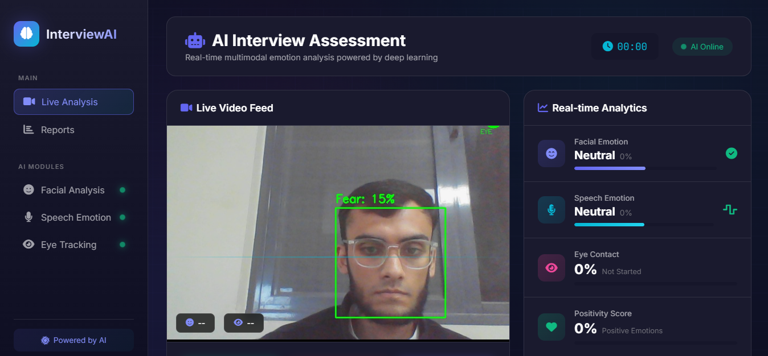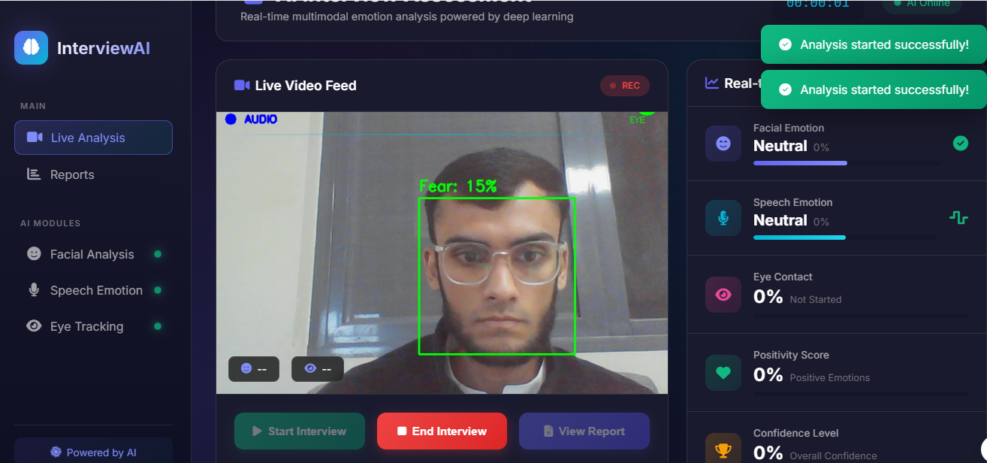

7.3 Strengths
- Multimodal Analysis: Combining face and speech provides more robust assessment than single-modality approaches
- Real-time Processing: Users receive immediate visual feedback during recording
- Actionable Recommendations: Prioritized suggestions help users focus on improvement areas
- Modular Architecture: Components can be updated or replaced independently
- Open-Source Models: Uses freely available pre-trained models, reducing development costs

7.4 Limitations
- Lighting Sensitivity: Facial emotion detection accuracy decreases in poor lighting
- Background Noise: Speech emotion recognition may be affected by ambient noise
- Single Face: System currently supports single-person interviews only
- Language Dependency: Speech model is trained on English audio data
- Hardware Requirements: Real-time processing requires adequate CPU/GPU resources

Model Accuracy and Evaluation
Model | Accuracy
Facial Emotion Recognition (CNN) | ~75%
Speech Emotion Recognition (Wav2Vec2) | ~82%

7.5 Discussions

The multimodal fusion approach proves effective in providing a holistic view of interview performance. The weighted scoring system appropriately prioritizes facial expressions (40%) and speech patterns (35%) as primary indicators, with eye contact (15%) and vocal confidence (10%) as supplementary metrics.
Test results indicate that the system accurately identifies common interview challenges such as lack of eye contact, nervous expressions, and emotional inconsistencies. The recommendation engine successfully maps detected issues to actionable improvement suggestions.

8. Conclusion and Future Work

8.1 Conclusion
The AI Interview Analyzer successfully demonstrates the application of multimodal emotion recognition for automated interview performance evaluation. By combining state-of-the-art deep learning models for facial emotion detection (FER2013 CNN) and speech emotion recognition (Wav2Vec2), the system provides objective, quantitative feedback that helps candidates improve their interview skills.
Key achievements include:
- Real-time analysis of both facial expressions and speech patterns
- Comprehensive scoring system with weighted multimodal fusion
- Automated generation of detailed reports with personalized recommendations
- User-friendly web interface accessible through standard browsers
- Modular architecture enabling easy maintenance and extension
The project addresses the fundamental problem of subjective interview evaluation by providing AI-driven, consistent, and accessible feedback to job seekers.

8.2 Future Work
Several enhancements are planned for future development:
- Body Language Analysis: Incorporate pose estimation to analyze body posture and gestures
- Natural Language Processing: Add speech-to-text transcription and content analysis for answer quality evaluation
- Multi-language Support: Extend speech emotion recognition to support multiple languages
- Mobile Application: Develop mobile apps for iOS and Android for on-the-go practice
- Cloud Deployment: Deploy on cloud platforms (Azure, AWS) for scalability and accessibility
- Historical Tracking: Implement user accounts to track progress over multiple sessions
- Interview Simulation: Add AI-generated interview questions with context-aware feedback
- Improved Models: Fine-tune emotion models on interview-specific datasets for higher accuracy
- Real-time Coaching: Provide instant suggestions during recording (e.g., "Smile more", "Look at camera")
- Integration APIs: Create APIs for integration with HR platforms and learning management systems

9. References
- Goodfellow, I. J., et al. (2013). "Challenges in Representation Learning: A Report on Three Machine Learning Contests." Neural Information Processing.
- Baevski, A., et al. (2020). "wav2vec 2.0: A Framework for Self-Supervised Learning of Speech Representations." NeurIPS 2020.
- Livingstone, S. R., & Russo, F. A. (2018). "The Ryerson Audio-Visual Database of Emotional Speech and Song (RAVDESS)." PLOS ONE.
- Baltrusaitis, T., Ahuja, C., & Morency, L. P. (2018). "Multimodal Machine Learning: A Survey and Taxonomy." IEEE Transactions on Pattern Analysis and Machine Intelligence.
- Mollahosseini, A., Hasani, B., & Mahoor, M. H. (2017). "AffectNet: A Database for Facial Expression, Valence, and Arousal Computing in the Wild." IEEE Transactions on Affective Computing.
- Ekman, P., & Friesen, W. V. (1971). "Constants Across Cultures in the Face and Emotion." Journal of Personality and Social Psychology.
- Schuller, B., et al. (2018). "Speech Emotion Recognition: Two Decades in a Nutshell, Benchmarks, and Ongoing Trends." Communications of the ACM.
- TensorFlow Documentation. (2023). "Keras API Reference." https://www.tensorflow.org/api_docs/python/tf/keras
- HuggingFace. (2023). "Transformers: State-of-the-art Machine Learning for PyTorch, TensorFlow, and JAX." https://huggingface.co/docs/transformers

